Pupil premium strategy statement – Highcliffe Primary School
This statement details our school’s use of pupil premium (and recovery premium) funding to help improve the attainment of our disadvantaged pupils.
It outlines our pupil premium strategy, how we intend to spend the funding in this academic year and the outcomes for disadvantaged pupils last academic year.

School overview
Detail | Data
Number of pupils in school | 242 FTE
Proportion (%) of pupil premium eligible pupils | 35.95%
Academic year/years that our current pupil premium strategy plan covers | 2024/25
Date this statement was published | December 2024
Date on which it will be reviewed | October 2025
Statement authorised by | Miss N. King
Pupil premium lead | Mrs A. Salter
Governor / Trustee lead | Mrs H. Wigham

Funding overview
Detail | Amount
Pupil premium funding allocation this academic year | £137,588
Pupil premium funding carried forward from previous years (enter £0 if not applicable) | £6,739
Total budget for this academic year | £144,327

Part A: Pupil premium strategy plan

Statement of intent
At Highcliffe Primary School, we want all children to have the opportunity to achieve their full learning potential. Academic and social success at Highcliffe is underpinned by our school motto; ‘With belief and hard work, anything is possible’, as well as our core values: Respect; Resilience and Responsibility. Supports us to ensure every pupil-especially our most vulnerable learners- achieves their full academic potential, whist enjoying their time at school. Our intention is that our Pupil Premium Funding
Our ultimate objective for our disadvantaged pupils is that their time at Highcliffe Primary is as successful and enjoyable as that of their peers. We aim for all children to develop their resilience, emotional well-being and behaviours so that they can learn effectively. We have always strived to make a difference and go the extra mile for our disadvantaged learners.
The EEF state that, “there is evidence that the attainment gap between socially disadvantaged pupils and their classmates has grown¹ [over the pandemic] therefore, for 2024-25 we have ascertained that the key areas for our disadvantaged pupils are academic progress and developing pupils’ resilience and emotional wellbeing. Whilst the pandemic is long behind us, the effects of lockdown are still evident in some classes.
Our approach will be responsive to common challenges and individual needs. The approaches we have adopted complement each other to help pupils thrive. To ensure that they are effective we will:
- Ensure disadvantaged children receive the support they need academically, socially and emotionally
- Ensure disadvantaged pupils are challenged in the work they are set
- Adopt a whole school approach in which all staff take responsibility for disadvantaged pupils’ outcomes and raise expectations of what they can achieve
¹ (EEF,2022) The Impact of Covid-19 on Learning

Challenges
This details the key challenges to achievement that we have identified among our disadvantaged pupils.
Challenge number | Detail of challenge
1 | We will continue to aim to close the attainment gap between disadvantaged and non-disadvantaged pupils through high quality teaching and interventions.  “High quality teaching—every day, for all pupils—can and will make a positive difference” (EEF, Moving Forwards, Making a Difference, 2022)
2 | Some of our learners had a very disrupted start to their schooling due to the pandemic and have missed fundamental learning, such as phonics, early language acquisition and key numeracy skills.  “There is some evidence that in primary schools, younger year groups (Key Stage 1 pupils) have been the most significantly affected, with lower attainment than previous cohorts across all subjects.” (EEF, The Impact of COVID-19 on Learning, 2022) (Note: The current Y5 children were in Reception in spring 2020)
3 | The wider effects of the pandemic have had a negative impact on children’s mental health. (EEF, The Impact of Covid-19 on learning, 2022)
4 | Attendance and punctuality of disadvantaged pupils.  “There is some evidence of promise for several strategies including parental engagement approaches and responsive interventions to target the individual causes of low attendance” Attendance Interventions Rapid Evidence Assessment (EEF, 2022)
5 | Ensure that financial barriers- especially with a backdrop of the ‘cost of living crisis’- are not a barrier to disadvantaged children taking part in extra-curricular events (such as trips, residentials, theatre visits, sporting events and after school clubs).

Intended outcomes
This explains the outcomes we are aiming for by the end of our current strategy plan, and how we will measure whether they have been achieved.
Intended outcome | Success criteria
Attainment gap between PPG and non-disadvantaged children continues to narrow and move towards pre-pandemic standards, as a result of quality first teaching and interventions. | The attainment gap from summer 2024 at the end of KS1 and KS2 will have narrowed by summer 2025, on average, for PPG pupils.
Our Y and Y3 pupils had their EYFS time disrupted so we aim to fill the gaps in both academic and social progress. | The number of PPG pupils achieving 20 marks and above on the MTC increases.  The attainment gap from summer 2024 for Y4 and Y5 PPG pupils in reading, writing and maths will have narrowed by summer 2025.  Children will be confident and independent.
Improved emotional wellbeing and mental health for our PPG pupils as well as supporting positive learning behaviours. | Reduced numbers of PPG children needing access to our school counsellor, ELSA practitioners, THRIVE practitioners and EMHP to work with pupils to support their mental health.
The attendance of our disadvantage pupils increases. | The attendance for our PPG children will be in line with national average.
PPG pupils have had the opportunity to attend extra-curricular events and personal finance is not a barrier to them attending. | The same proportion of PPG pupils attend residentials, trips and sports events as non-disadvantaged pupils.

Activity in this academic year
This details how we intend to spend our pupil premium (and recovery premium) funding this academic year to address the challenges listed above.

Teaching (for example, CPD, recruitment and retention)
Budgeted cost: £123,320
Activity | Evidence that supports this approach | Challenge number(s) addressed
PP children have access to high quality teaching.  PP children have more 1:1 and focus group sessions with the teacher than non-PP children | - “Developing high quality teaching, assessment and a curriculum which responds to the needs of pupils” DfE – Menu of Approaches, Using pupil premium guidance for school leaders 2022  - “Different methods of feedback delivery can be effective and feedback should not be limited exclusively to written marking. Studies of verbal feedback show slightly higher impacts overall (+7 months)” EEF- T&L Toolkit  - “One to one and small group tuition” DfE – Menu of Approaches, Using pupil premium guidance for school leaders 2022  - https://educationendowmentfoundation.org.uk/education-evidence/teaching-learning-toolkit/one-to-one-tuition EEF  - https://educationendowmentfoundation.org.uk/education-evidence/teaching-learning-toolkit/small-group-tuition EEF | 1,4
Children in EYFS will read weekly 1:1 and receive intervention for early reading and writing skills. Children will take part in BLAST used in Nursery, NELI (Nursery and |Reception) and Early Talk boost (Nursery)  Children will participate in ‘Tales Toolkit’ which supports communication and language skills, as well as writing skills. | - “One to one and small group tuition” and “Interventions to support language development and literacy” DfE-Menu of approaches, Using pupil premium guidance for school leaders 2022  - https://educationendowmentfoundation.org.uk/education-evidence/teaching-learning-toolkit/small-group-tuition EEF  - https://educationendowmentfoundation.org.uk/education-evidence/teaching-learning-toolkit/one-to-one-tuition EEF  - https://educationendowmentfoundation.org.uk/education-evidence/teaching-learning-toolkit/oral-language-interventions EEF | 1,4
Children in Nursery, Reception and Year 1 will undertake continuous provision.  Continuous Provision resources purchased for Reception and Year 1. | - Carefully planned continuous provision will enable children to learn skills, will challenge their thinking and help them to embed concepts. Research continually tells us that young children learn best through play and exploration.  - Play-based approaches can have substantial benefits for children who are identified as having social, emotional, or educational difficulties. (EEF) | 1,2,3,4
1 x full time Lead Thrive Practitioner to work with targeted children in KS1 and KS2 including liaison with parents of children accessing provision.  1 x 0.6 Nurture trained teacher to work with targeted children in EYFS including liaison with parents of children accessing provision. | - The EEF Guidance report ‘Improving Social and Emotional Learning in Primary Schools’ advocates teaching Social and Emotional Learning skills explicitly and integrating and modelling social and emotional learning skills through everyday teaching.  - Social and emotional learning approaches have a positive impact, on average, of 4 months’ additional progress in academic outcomes over the course of an academic year.  - https://educationendowmentfoundation.org.uk/education-evidence/teaching-learning-toolkit/social-and-emotional-learning EEF | 1,2,3,4.
SoundsWrite training for staff.  English lead to disseminate Reading for Pleasure: Transforming your school’s reading culture’ training to staff.  Bottom 20% across school targeted for extra phonics and reading interventions. | - The Reading Framework (DfE, 2021) highlights the importance of a systematic synthetic phonics.  - Sounds Write is a validated SSP program.  - The Education Endowment Fund Teaching Toolkit (EEF, 2021) highlights Phonics as having high impact for low cost based on extensive evidence.  - A key recommendation of the EEF Guidance report ‘Improving Literacy in Key Stage 1’ is to effectively implement a systematic phonics programme. This report recommends considering the following when choosing a phonics program: training, responsiveness, engagement, adaptations and focus.  - The evidence tells us that high quality teaching is the most important factor when it comes to improving attainment outcomes, particularly for disadvantaged pupils. (EEF, Moving Forwards, Making a Difference, 2022) | 1,2

Targeted academic support (for example, tutoring, one-to-one support, structured interventions)
Budgeted cost: £17,779
Activity | Evidence that supports this approach | Challenge number(s) addressed
Sounds Write interventions  for targeted children to develop reading fluency in EYFS, KS1 and KS2. | - The EEF Guidance Report ‘Making Best Use of Teaching Assistants’ highlights the benefits of using TAs to deliver high quality one to one and group support using structured interventions. Sounds Write offers a structured and consistent approach to the teaching phonics for both whole class work and small group intervention.  https://educationendowmentfoundation.org.uk/education-evidence/teaching-learning-toolkit/teaching-assistant-interventions  https://educationendowmentfoundation.org.uk/education-evidence/teaching-learning-toolkit/small-group-tuition | 1,2,4
PPG pupils not on track to meet age-related expectations will be identified through our PPG tracker and will receive high-quality extra support from teachers and teaching assistants. Progress monitored on PPG tracker. | - “One to one and small group tuition” and “Interventions to support language development and literacy” DfE – Menu of Approaches, Using pupil premium guidance for school leaders 2022  - Small group tuition has an average impact of four months’ additional progress over the course of a year.Small group tuition is most likely to be effective if it is targeted at pupils’ specific needs. Diagnostic assessment can be used to assess the best way to target support. One-to-one tuition and small group tuition are both effective interventions.  - Additional small group support can be effectively targeted at pupils from disadvantaged backgrounds, and should be considered as part of a school’s pupil premium strategy.  https://educationendowmentfoundation.org.uk/education-evidence/teaching-learning-toolkit/small-group-tuition  EEF  https://educationendowmentfoundation.org.uk/education-evidence/teaching-learning-toolkit/teaching-assistant-interventions EEF  https://www.gov.uk/guidance/pupil-premium-effective-use-and-accountability EEF | 1,4

Wider strategies (for example, related to attendance, behaviour, wellbeing)
Budgeted cost £3,228
Activity | Evidence that supports this approach | Challenge number(s) addressed
We will continue to offer to financially subsidise outdoor educational residentials and other visits in 24/25. | Extracurricular activities, including sports, outdoor activities, arts, culture and trips” DfE – Menu of Approaches, Using pupil premium guidance for school leaders 2022  https://educationendowmentfoundation.org.uk/education-evidence/teaching-learning-toolkit/outdoor-adventure-learning EEF | 2,5
Employment of Attendance Officer (weekly) to work with families falling below our targets. Teachers to have meetings with parents to discuss attendance and punctuality. Close monitoring of PPG pupils’ attendance using PPG tracker.  Weekly reviews of attendance by AO. | “Supporting attendance” DfE – Menu of Approaches, Using pupil premium guidance for school leaders 2022  https://educationendowmentfoundation.org.uk/guidance-for-teachers/using-pupil-premium EEF  In order for children to thrive at school, the positive interventions in terms of behaviour, attendance and achievement can have a significant impact on the attainment of all disadvantaged children. The EEF has researched that it can add up to 4 months onto the progress of children. EEF | 1,2,3,4
Mental wellbeing:  Employment of an Emotional Mental Health Practitioner (EMHP) part of the Inside Out Mental Health support team to work with children and families identified as needing extra support. | “Supporting pupils’ social, emotional and behavioural needs” “Supporting attendance” DfE – Menu of Approaches, Using pupil premium guidance for school leaders 2022  “It is recognised that the Covid-19 pandemic has had wider impacts on pupils aside from attainment, which this report focuses on. There is evidence that suggests the pandemic has negatively impacted children’s mental health. More research is needed to understand the long-term effects of the Covid-19 pandemic on children’s mental health and the influence of specific risks factors as they evolve over time.” (Bus-sières et al., 2021).  While there is limited data, teachers have identified mental health as a significant challenge in the classroom. (The Impact of COVID-19 on Learning: A review of the evidence, EEF) | 2,3

Total budgeted cost: £144,327

Part B: Review of the previous academic year

Pupil Premium strategy outcomes for 2023/24
2024 Data
Challenges identified 2023-2024
Intended Outcome:
- Attainment gap between PPG and non-disadvantaged pupils continues to narrow and move towards pre-pandemic standards, as a result of quality first teaching and interventions.

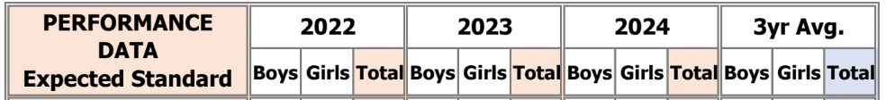
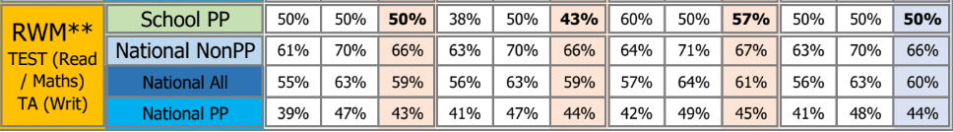
KS2 Attainment

The number of disadvantaged children who took the KS2 test was 21 out of 51. The percentage of PPG pupils achieving the expected standard in reading, writing and maths (RWM) was 57%. The percentage of National All pupils achieving the expected standard in RWM was 61%. No children achieved a higher score in RWM combined.

KS1 Attainment
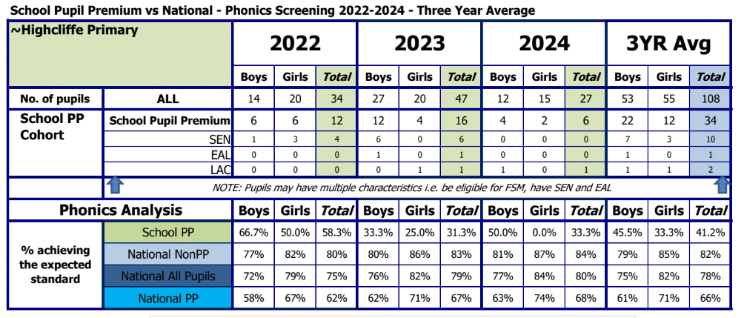
The number of disadvantaged pupils who took the phonics screening check was low, therefore the data must be interpreted carefully. 22% of pupils are Disadvantaged - 6 pupils (4 boys and 2 girls). 33% of Disadvantaged pupils achieved the standard compared to 80% of National All pupils.
Phonics is taught well at Highcliffe. We have graduated from the English Hubs programme (DfE) by completing 6+ days of Literacy Specialist support with good engagement, as well as demonstrating our commitment to build on and sustain good practice in early reading. All staff are fully SoundsWrite trained. Children who need additional support with their phonics learning are quickly identified and undertake additional phonics sessions, alongside their whole class phonics teaching. Trained staff are re-deployed to run additional SoundsWrite sessions in EYFS and KS1 to target specific groups of children and ensure all children make at least good progress.
Intended outcome:
Our Year 3 and 4 pupils have had their EYFS time disrupted therefore we aim to fill the gaps in both academic and social progress.
The average score for the multiplication check for PPG pupils in 2023-2024 was 20 out of 25. The average score for PPG pupils was 18.4 out of 25. The average score for PPG pupils is less than in 2023, however, the number of PPG pupils in 2023 was less than half compared to 2024. Times Tables practice forms part of the daily active maths sessions in LKS2. All children are regularly assessed on the recall of their multiplication facts and interventions are put in place for children who need extra support.
Pupils in Year 3 and 4 are supported by teaching staff and teaching assistants to work towards filling any gaps in their social, emotional and mental health progress. Pupils undertake regular assemblies, workshops and PSHE sessions which address any issues which arise. Our Mental Health Lead continues to work with pupils in KS2 to become peer mentors for mental health (Headstarters). They mentor their peers to help develop their confidence and leadership skills. Children who are identified as having SEMH needs are discussed with our SENDco and Mental Health Lead. SLT meet regularly with our EMHP at Huddle meetings and the best course of action for each child is decided upon; whether this be working with our school counsellor, ELSA and Thrive Practitioner or a referral made to outside agencies.
Intended outcome:
Improved emotional wellbeing and mental health for our PPG pupils as well as supporting positive learning behaviours.
The school has a number of staff trained in SEMH who deliver interventions to ensure that we are doing the very best for all children at Highcliffe, regardless of their status. Referrals to our SEMH team are made by parents and staff. Individual children are discussed at Huddle meetings with our EMHP and a course of action for each child is decided upon. This can be ‘in house’ or accessing the support of outside agencies.
We currently have 23 PPG children who are either accessing support or on the waiting list to be seen regarding SEMH needs. All PPG children are monitored closely and put forward for interventions if necessary.
Intended outcome:
The attendance of our disadvantaged pupils increases.
Attendance for PP children in 2022-23 was 91.84%
Attendance for PP children in 2023-24 was 93.7%
This is below our whole school target of 96%.
Attendance for PPG children rose slightly, however, it was still below our target of 96%. Analysis shows that a small number of PPG families take holidays (always unauthorised) during term time which affects the attendance figures.
Intended outcome:
PPG pupils have had the opportunity to attend extra-curricular events and personal finance is not a barrier to them attending.
All PPG children are offered the same experiences in school as Non-PPG children and are encouraged to attend extra-curricular events. School has subsidised trips and residentials for PPG children and will continue to do so. PPG children who attend clubs and extra-curricular events are logged on school’s PPG tracker.

Externally provided programmes
Please include the names of any non-DfE programmes that you used your pupil premium to fund in the previous academic year.
Programme | Provider
Thrive Approach | Thrive

